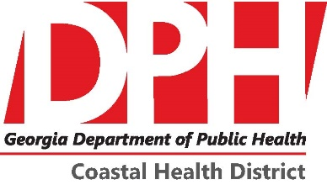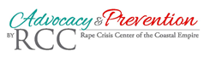
Save a Life Youth Health Summit
Saturday, June 23rd at 9am -4pm
Youth Ages 10-19; Parents & Educators are welcome
Registration Form
Youth Participant
Name:____________________________________________
Phone:_________________ Email:________________________
Grade:_______________ Age:__________
Attending CPR Certification Class: YES or NO

Parent/Educator Participant
Name:____________________________________________
Phone:_________________ Email:________________________
Parent or Educator?__________________
Attending CPR Certification Class: YES or NO

